Lab: Methods
Problems for in-class lab for the "C# Fundamentals" course @ SoftUni
You can check your solutions in Judge

Declaring and Invoking Methods

Sign of Integer Numbers
A single integer is given, create a method that checks if the given number is positive, negative, or zero. As a result print:
- For positive number: "The number {number} is positive. "
- For negative number: "The number {number} is negative. "
- For zero number: "The number {number} is zero. "

Examples
Input | Output
2 | The number 2 is positive.
-9 | The number -9 is negative.

Grades
Create a method that receives a grade between 2.00 and 6.00 and prints the corresponding grade definition:
- 2.00 – 2.99 - "Fail"
- 3.00 – 3.49 - "Poor"
- 3.50 – 4.49 - "Good"
- 4.50 – 5.49 - "Very good"
- 5.50 – 6.00 - "Excellent"

Examples
Input | Output
3.33 | Poor
4.50 | Very good
2.99 | Fail

Hints
- Read the grade from the console and pass it to a method
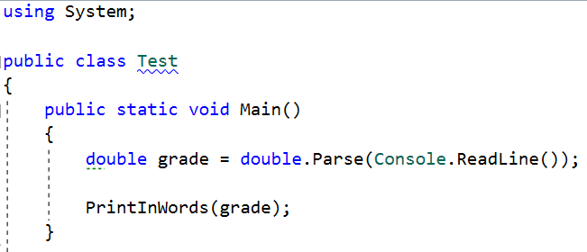
- Then create the method and make the if statements for each case
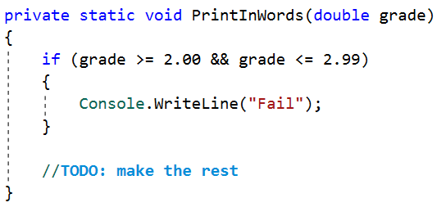

Calculations
Create a program that receives three lines of input:
- On the first line, a string - "add", "multiply", "subtract", "divide"
- On the second line, a number
- On the third line, another number
You should create four methods (for each calculation) and invoke the corresponding method depending on the command. The method should also print the result (needs to be void).

Example
Input | Output
subtract  5  4 | 1
divide  8  4 | 2

Hints
- Read the command on the first line and the two numbers, and then make an if/switch statement for each type of calculation
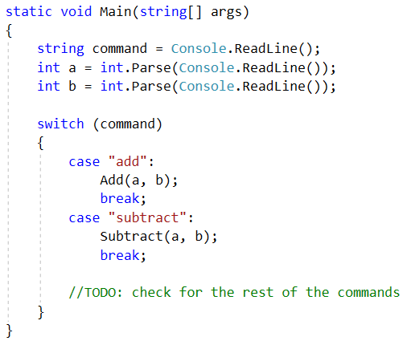
- Then create the four methods and print the result
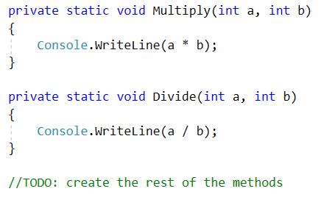

Printing Triangle
Create a method for printing triangles as shown below:

Examples
Input | Output
3 | 1  1 2  1 2 3  1 2  1
2 | 1  1 2  1

Hints
- After you read the input
- Start by creating a method for printing a single line from a given start to a given end. Choose a meaningful name for it, describing its purpose:
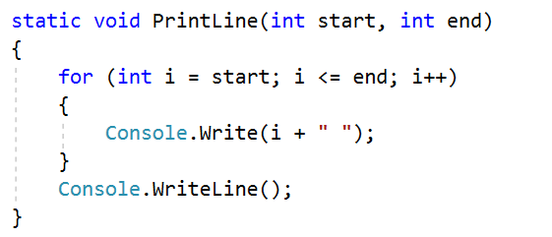
- Create another method for printing the whole triangle. Again choose a meaningful name for it, describing its purpose.
- Think how you can use the PrintLine() method to solve the problem
- After you spent some time thinking, you should have concluded that you will need two loops
- In the first loop you can print the first half of the triangle:
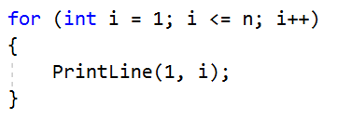
- In the second loop you can print the second half of the triangle:
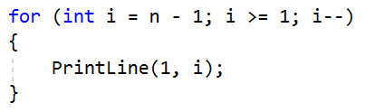

Orders
Create a program that calculates and prints the total price of an order. The method should receive two parameters:
- A string, representing a product - "coffee", "water", "coke", "snacks"
- An integer, representing the quantity of the product
The prices for a single item of each product are:
- coffee – 1.50
- water – 1.00
- coke – 1.40
- snacks – 2.00
Print the result rounded to the second decimal place.

Example
Input | Output
water  5 | 5.00
coffee  2 | 3.00

Hints
- Read the first two lines
- Create a method the pass the two variables in
- Print the result in the method

Returning Values and Overloading

Calculate Rectangle Area
Create a method that calculates and returns the area of a rectangle.

Examples

Input | Output
3  4 | 12
6  2 | 12

Hints
- After reading the input
- Create a method, but this time instead of typing "static void" before its name, type "static double" as this will make it return a value of type double:
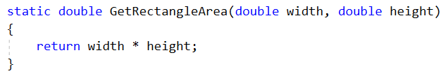
- Invoke the method in the main and save the return value in a new variable:
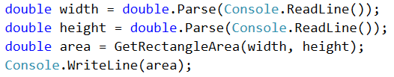

Repeat String

Create a method that receives two parameters:

A string

A number n (integer) represents how many times the string will be repeated

The method should return a new string, containing the initial one, repeated n times without space.

Example
Input | Output
abc  3 | abcabcabc
String  2 | StringString

Hints
- Firstly read the string and the repeat count n
- Then create the method and pass it the variables
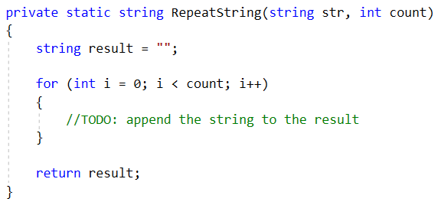
- In the main method, print the result

Math Power
Create a method, which receives two numbers as parameters:
- The first number – the base
- The second number – the power
The method should return the base rase to the given power.

Examples
Input | Output
2  8 | 256
3  4 | 81

Hints
- As usual, read the input
- Create a method that will have two parameters - the number and the power, and will return a result of type double:
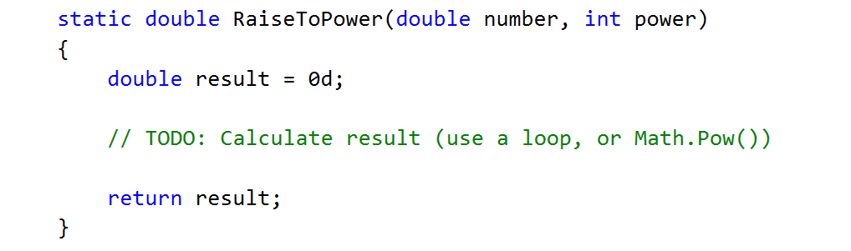
- Print the result

Greater of Two Values
You are given an input of two values of the same type. The values can be of type int, char, or string. Create methods called GetMax(), which can compare int, char, or string and returns the biggest of the two values.

Examples
Input | Output
int  2  16 | 16
char  a  z | z
string  aaa  bbb | bbb
Hint: Use method overloading.

Multiply Evens by Odds
Create a program that multiplies the sum of all even digits of a number by the sum of all odd digits of the same number:
- Create a method called GetMultipleOfEvenAndOdds()
- Create a method GetSumOfEvenDigits()
- Create GetSumOfOddDigits()
- You may need to use Math.Abs() for negative numbers

Examples
Input | Output | Comment
-12345 | 54 | Evens: 2 4  Odds: 1 3 5  Even sum: 6  Odd sum: 9  6 * 9 = 54
3453466 | 220
- Math Operations
Write a method that receives two numbers and an operator, calculates the result, and returns it. You will be given three lines of input. The first will be the first number, the second one will be the operator and the last one will be the second number.
The possible operators are: /, *, + and -.

Example
Input | Output
5  *  5 | 25
4  +  8 | 12

Hint
- Read the inputs and create a method that returns a double (the result of the operation)
